SE Lab 1
Name - Tanvi. B. Shetty
SRN - PES1UG24AM302
Section - F

Deliverable 1
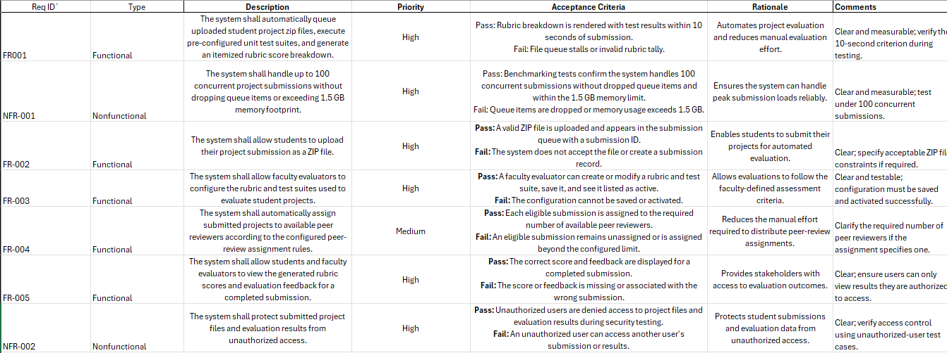

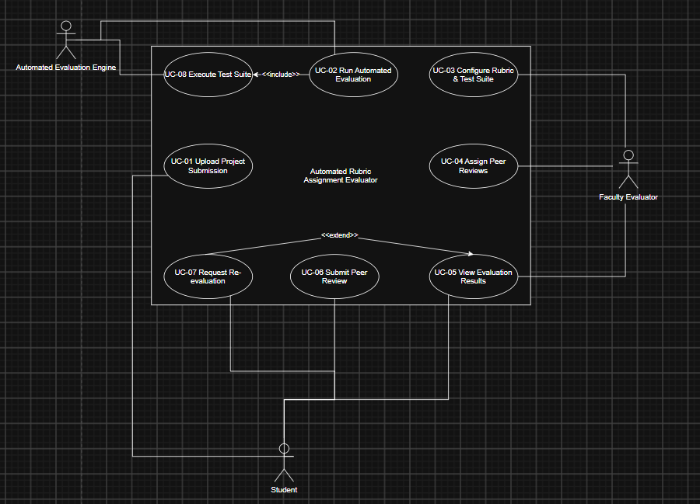
Deliverable 2
Deliverable 3
Use Case: UC-02 — Run Automated Evaluation

Preconditions
- The student has uploaded a project submission as a ZIP file.
- The submission has been added to the evaluation queue.
- A pre-configured unit test suite and rubric are available for the submission.

Postconditions
- The project's unit test results have been generated and recorded.
- An itemized rubric score breakdown has been generated.
- The evaluation results are available for the student and faculty evaluator.

Main Success Scenario
- The system retrieves the student's project submission from the evaluation queue.
- The system validates the submitted project file.
- The system retrieves the pre-configured unit test suite.
- The system executes the unit tests on the submitted project.
- The system collects and records the test results.
- The system applies the configured rubric to the test results.
- The system calculates the score for each rubric criterion.
- The system generates an itemized rubric score breakdown.
- The system stores the completed evaluation results.
- The system makes the evaluation results available to the student and faculty evaluator.

Alternate Flow — Invalid Submission
At Step 2:
- The system detects that the submitted project is invalid or cannot be processed.
- The system displays an error message to the student.
- The system marks the submission as invalid.
- The system does not execute the test suite or generate a rubric score.
- The student is prompted to upload a corrected submission.

